# 30 June 2016

**Miling of Chromium coated SiN membrane.  
Piercing through the membrane with different doses**

**11:30 – exp6-7**

**Parameters :**

|  |  |
| --- | --- |
| Coating | 5 nm Cr |
| Thickness | 5 + 100 nm |
| Beam | 35kV 20µm (8) 6.0pA |
| Measured current | 6.75 then 6.97 pA |
| Loop Factor | 20 |
| Line Dose | 1000 then 3000 µC/cm |
| Dot dose | 0.10044 then 0.8 pC |
|  |  |
| Design | *Multiple fall* |
| Design Dose factor | *1* |

**Experiment and Results:**

Left: Line dose 1000 and Dot dose 0.10044  
Right: Line dose 3000 and Dot dose 0.8  
From left to right: dose factor 1 to 1.8 (step: 0.2)

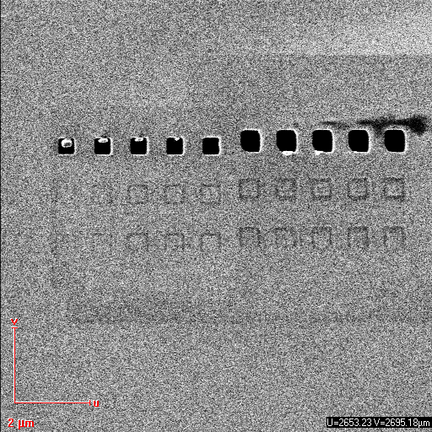

A dose of 20*0.10044*1=**2.0088pC** is enough to pierce through the membrane with dots. For low doses a part of the membrane seems to hold on to a border:  
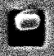

Concerning lines, a dose of 1.8*20*3000µC*0.0032=**345.6µC** is not enough to pierce through the membrane.

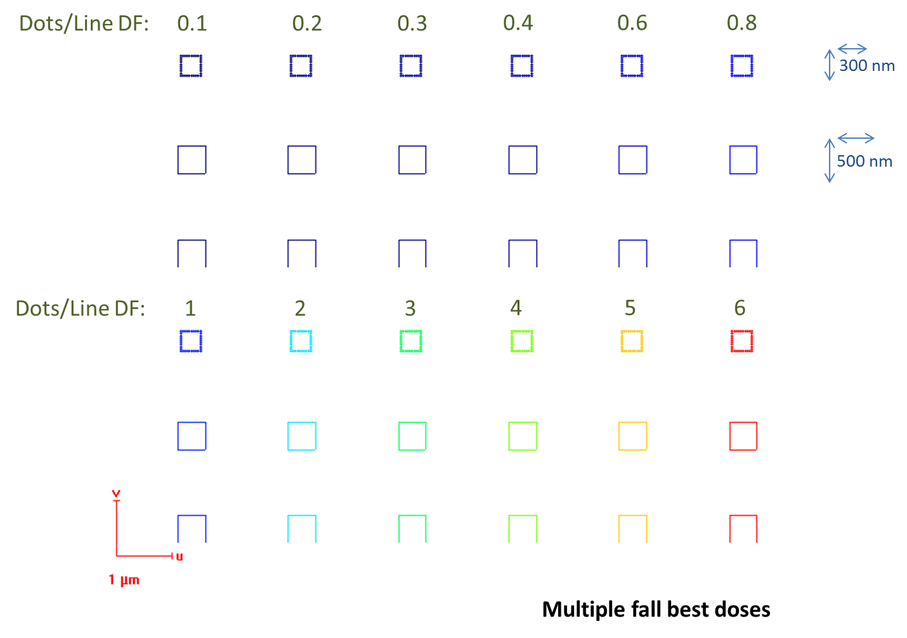***To bring forward the importance of doses, we will use a new design:*** *multiplefall-bestdoses* ***composed of dose factors: 0.1; 0.2; 0.3; 0.4; 0.6; 0.8 on a first line, and 1 to 6 on a second line:***

**12:15 – exp8**

**Parameters :**

|  |  |
| --- | --- |
| Coating | 5 nm Cr |
| Thickness | 5 + 100 nm |
| Beam | 35kV 20µm (8) 6.0pA |
| Measured current | 6.83 pA |
| Loop Factor | 20 |
| Line Dose | 1000 µC/cm |
| Dot dose | 0.1 pC |
|  |  |
| Design | *Multiple fall best doses* |
| Design Dose factor | *1* |

**Experiment and Results:**

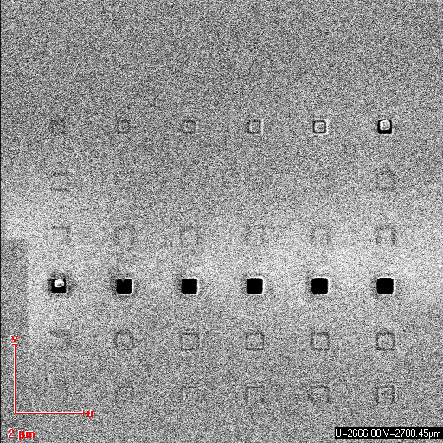

The dot at dose factor 0.6 does not pierce the membrane, contrarily to the dot at 0.8:  
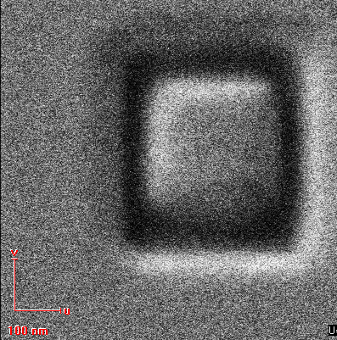 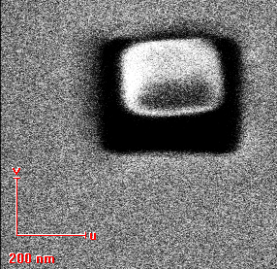

Therefore, the limit dot dose to pierce through the membrane is supposed to be between 20*0.1*0.6=**1.2pC** and **1.6pC.** Moreover a line dose of 20*1000*6*0.0032=**384µC** is not enough.

**12:30 – exp9**

**Parameters :**

|  |  |
| --- | --- |
| Measured current-pA | 6.978 |
| Loop Factor | 20 |
| Dot Dose-pC | 0.1 |
| Line Dose-µC/cm | 1000 |
| Area Dose | 1000 |
|  |  |
| Design | *Fptriangle2* |
| Design Dose factor | *1* |

**Experiment and Results:**

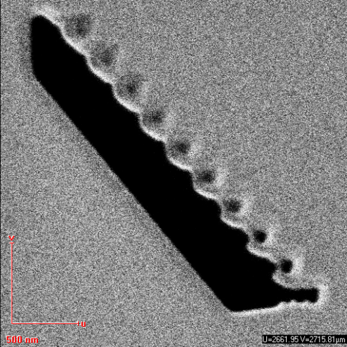

**12:50 – exp10-11**

**Parameters :**

|  |  |  |
| --- | --- | --- |
| Measured current-pA | 6.832 | 6.846 |
| Loop Factor | 20 | 20 |
| Dot Dose-pC | 0.1 | 0.08 |
| Line Dose-µC/cm | 5000 | 7000 |
| Area Dose | 1000 | 1000 |
|  |  |  |
| Design | *Multiple fall best doses* | *Multiple fall best doses* |
| Design Dose factor | *1* | *1* |
| Note | *Badly positioned* | *Badly positioned but right part ok* |

**Experiment and Results:**

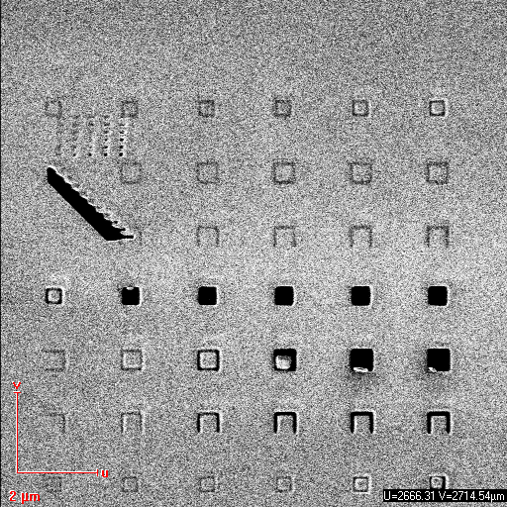

Image 1 (exp10) shows the same results concerning the dot dose as exp8 and that a total line dose of 0.0032*20*5000*6=1920µC is not enough to pierce the membrane.  
Image 2 (exp11) shows that a limit for the dot dose to pierce through should be between 1.6 and 3.2pC (dose factor 1 and 2), but that contradicts the limit found at experience 9: [1.2,1.6pC]

|  |  |
| --- | --- |
|  |  |
| Dose factor 1 Dot dose 0.08 | Dose factor 0.8  Dot dose 0.1 |

We assume that the limit dose is around **1.6pC**.

Maybe a higher dot dose and a lower dose factor mills better, or maybe the experiment is not entirely repeatable.

Concerning lines the limit is between dose factor 3 and 4, so in **[1344,1792]µC**  
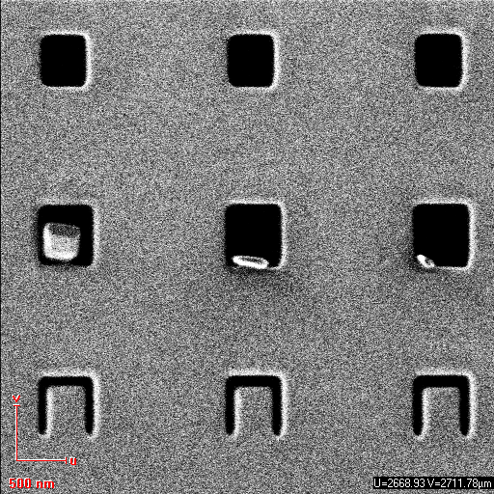  
 *Line miling at dose factor 4 - 5 - 6*

**13:30-15:00 – exp12to15**

*Another way to know if we pierce through is to compare the contrast with the one of a big, piercing through, area.  
Here we will not study the resolution.*

**Parameters :**

|  |  |  |  |  |
| --- | --- | --- | --- | --- |
| Measured current-pA | 6.953 | 6.992 | ~6.99 | 6.99 |
| Loop Factor | 20 | 20 | 20 | 200 |
| Dot Dose-pC | 0.08 | 0.08 | 0.1 | 0.01 |
| Line Dose-µC/cm | 7000 | 35000 | 20000 | 1800 |
| Area Dose | 1000 | 1000 | 1000 | 100 |
|  |  |  |  |  |
| Design | *Fp rectangle* | *Fp rectangle* | *Fp rectangle* | *Fp rectangle* |
| Design Dose factor | *1* | *1* | *1* | *1* |

**Experiment and Results:**

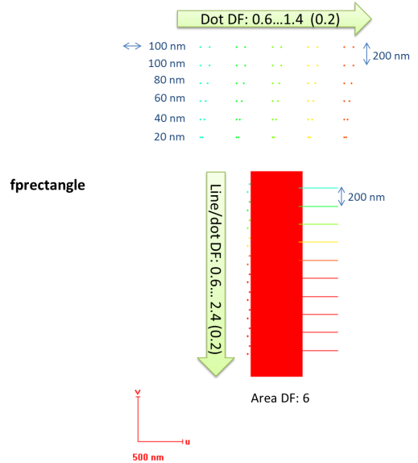 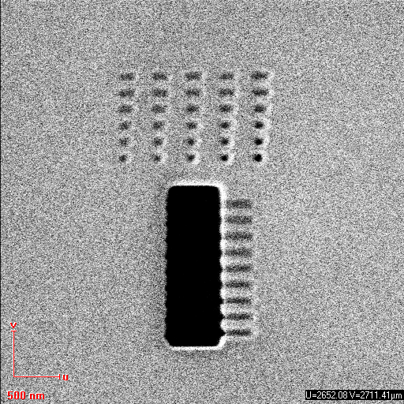 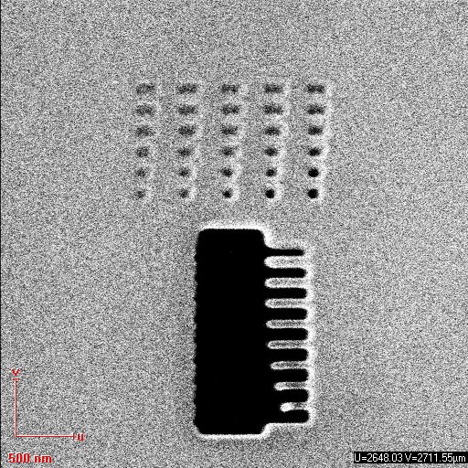  
  
Exps 12 and 13 show that the necessary total line dose to mill through is between 0.0032*20*7000*2.4 and 0.0032*20*35000*0.6µC, said **[1075,1344]µC.** This is strange because for experience 11, 1344µC was not enough.!  
We can assume that the milling of the big area had enhanced the further milling of the adjacent membrane, so we will find a limit that is lower than the real one, which concerns isolated lines.

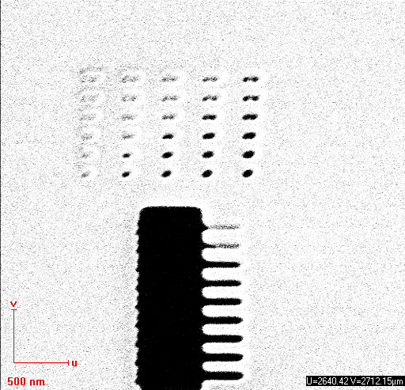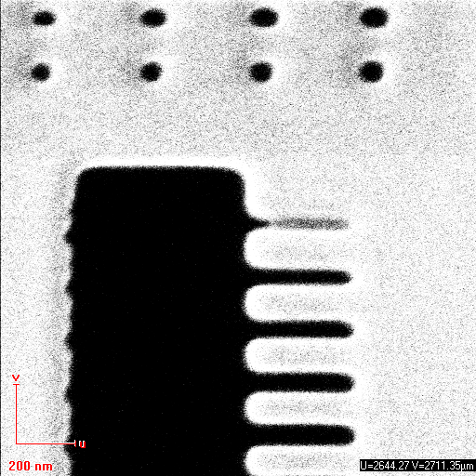

Exps 14 and 15 show that the limit is between [768,1024] and [922,1152]µC, so that is **[922,1024]µC**.  
Again, we find a lower limit than with the use of “multiple-fall”.

While the lines pierce the membrane for a dose factor 0.8 in exp 15, ie 1024µC, it does not in exp 12 for dose factor 2.4, ie 1075.2µC: For a same number of loop, a higher line dose and a low dose factor seems to be better than the opposite balance. This is opposite to what we found about dots…

**15:10 – exp16**

**Parameters :**

|  |  |  |  |  |
| --- | --- | --- | --- | --- |
| Measured current-pA |  |  |  | 6.99 |
| Loop Factor |  |  |  | 200 |
| Dot Dose-pC |  |  |  | 0.01 |
| Line Dose-µC/cm |  |  |  | 1800 |
| Area Dose |  |  |  | 100 |
|  |  |  |  |  |
| Design |  |  |  | *Multiple fall best doses* |
| Design Dose factor |  |  |  | *1* |

**Experiment and Results:**

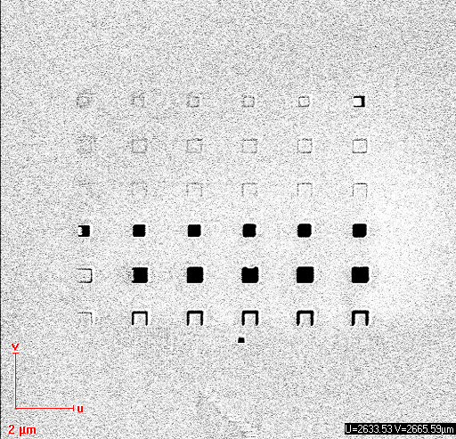

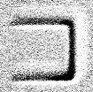This show that the dot dose necessary to pierce the membrane is **between 1.2 and 1.6 pC**, and for lines **between 1152 and 2304µC.** Previously we found [1344,1792]µC for loop:20**,** that matches**.**

We notice that the line at dose factor 1 is non uniformly milled.  
This may be due to an increasing heat, assuming the beam started to mill the left part, that enhances the further milling of the membrane.

**16:45 – exp17**

**Parameters :**

|  |  |  |  |  |
| --- | --- | --- | --- | --- |
| Measured current-pA |  |  |  | 7.027 |
| Loop Factor |  |  |  | 1 |
| Dot Dose-pC |  |  |  | 2.0088 |
| Line Dose-µC/cm |  |  |  | 20000 |
| Area Dose |  |  |  | 20000 |
|  |  |  |  |  |
| Design |  |  |  | *Resolution dots* |
| Design Dose factor |  |  |  | *1* |

**Experiment and Results:**

*Not treated here –*

**16:45 – exp18**

**Parameters :**

|  |  |  |  |  |
| --- | --- | --- | --- | --- |
| Measured current-pA |  |  |  | 7.148 |
| Loop Factor |  |  |  | 1 |
| Dot Dose-pC |  |  |  | 2.0088 |
| Line Dose-µC/cm |  |  |  | 20000 |
| Area Dose |  |  |  | 20000 |
|  |  |  |  |  |
| Design |  |  |  | *Multiple fall best doses* |
| Design Dose factor |  |  |  | *1* |

**Experiment and Results:**

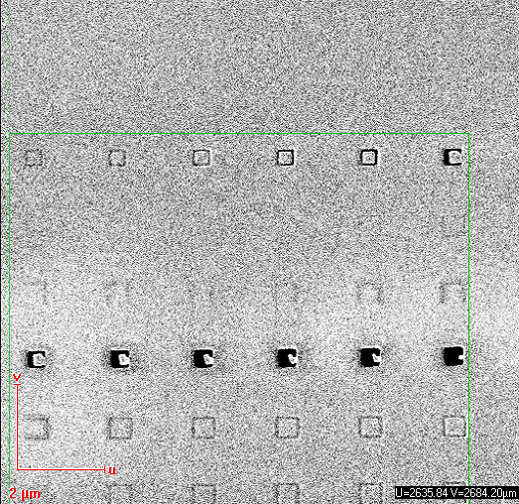  
First, we notice that the square of lines at dose factor 1 seems to always have troubles, concerning the milling of the left part. The other squares seem good so that may be a software issue, when the beam moves from far away  
A line dose of 384µC does not pierce. Concerning dots, dose factor of 0.4 and 0.6 do pierce the membrane, but a corner of the square has not been correctly milled:  
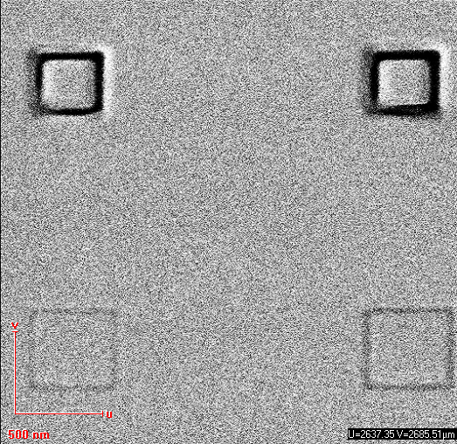

Therefore, the total dot dose that is necessary is in **[0.603,0.803]pC**